Project Report Format

# INTRODUCTION

* 1. Project Overview
  2. Purpose

# IDEATION PHASE

* 1. Problem Statement
  2. Empathy Map Canvas
  3. Brainstorming

# REQUIREMENT ANALYSIS

* 1. Customer Journey map
  2. Solution Requirement
  3. Data Flow Diagram
  4. Technology Stack

# PROJECT DESIGN

* 1. Problem Solution Fit
  2. Proposed Solution
  3. Solution Architecture

# PROJECT PLANNING & SCHEDULING

* 1. Project Planning

# FUNCTIONAL AND PERFORMANCE TESTING

* 1. Performance Testing

# RESULTS

* 1. Output Screenshots

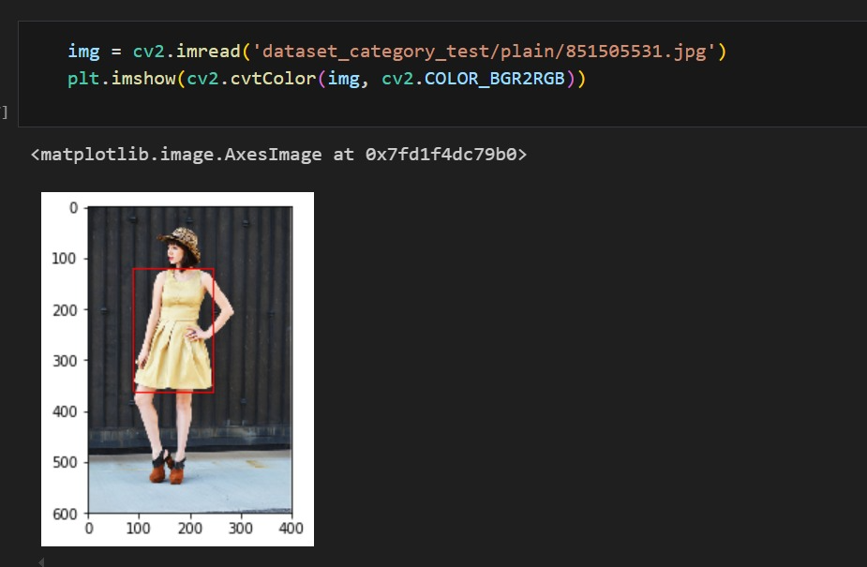

1. **ADVANTAGES & DISADVANTAGES**

**Advantages**

* Enables fast and accurate classification of fabric patterns, reducing manual effort.
* Supports better quality control by consistently identifying fabric types.
* Helps streamline production planning and inventory management.
* Reduces human errors in sorting and tagging different fabric patterns.
* Can be scaled to handle large numbers of samples in factories or warehouses.

**Disadvantages**

* Accuracy heavily depends on the quality and diversity of the dataset used.
* Struggles with rare or traditional patterns not present in the training data.
* Requires high computational resources for training and sometimes for inference.
* Model interpretability is limited — it can be hard to understand why a specific misclassification happens.
* Initial setup and integration into production lines can be costly and time-consuming.

1. **CONCLUSION**

In this project, a deep learning model was developed to classify various fabric patterns automatically. The approach reduces dependency on manual inspection, improves consistency, and enhances efficiency in textile manufacturing workflows. By leveraging computer vision and deep learning, this system provides a significant step toward smart textile production and quality assurance. Although there are challenges related to dataset limitations and model explainability, the results show promising accuracy and practical value in real-world applications.

1. **FUTURE SCOPE**

Expand the dataset to include more traditional and rare fabric patterns, increasing model robustness.

Integrate confidence score visualization in the UI to improve transparency for users.

Deploy the model in real-time quality control systems on the factory floor.

Explore lightweight model versions to allow edge deployment on handheld devices for field inspections.

Introduce continuous learning where the model gets updated as new patterns are added.

Integrate with ERP (Enterprise Resource Planning) systems to automate stock and supply chain decisions.

1. **APPENDIX**

Source Code(if any) Dataset Link

GitHub & Project Demo Link